35.28: The distance between maxima is
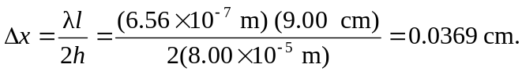
So the number of fringes per centimeter is 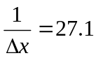fringes/cm.

